

Seaton Primary School
Behaviour Policy
This policy must be read in conjunction to our anti-bullying policy

At Seaton Primary, together we nurture an inclusive, child-centred school experience. Our ambitious and inspiring curriculum enables all pupils to succeed; children fulfil their potential and thrive in their next steps and beyond. We embrace the richness of our local environment and community to inspire, empower and create a sense of belonging.

We are proud of who we are and what we achieve together.

Date of development: 23.10.26
Date Agreed by Governors: Review Date: 04.11.26

Statement of Intent:

This policy has been written for the staff, pupils, governors and families of Seaton Primary School and any other stakeholders who contribute to the Behaviour Policy.

At Seaton, we promote and expect high standards of behaviour at all times in lessons and throughout every aspect of school life. In order to maximise learning we empower pupils to take responsibility for their own behaviour and learning.
The philosophy and pedagogy that underpins and drives our behaviour policy and practice is a restorative research-based approach linked to the books “When the adults change everything changes, a seismic shift in school behaviour” and “ Achieving Behaviour Nirvana” by Paul Dix.

CONTENTS:

- Key points
- Teacher and TA standards
- Policy Aims
- Behaviour Principles
- Building relationships with children
- Ensuring visible consistency
6b: Classroom routines
- Seaton School Values
- Rewards and sanctions including the Time out system
- Key Principles for Senior Leadership team
- Behaviour Check list for Teachers
- Playtime and Lunchtime Procedures
- Pupils’ conduct outside the school gates
- Confiscation of inappropriate items
- Physical Restraint

Appendices:
Behaviour poster
Reflection sheets
Values poster
One Page Policy
The Behaviour Curriculum Blueprint

1. Key points

- Teachers have a statutory authority to discipline pupils whose behaviour is unacceptable, who break the school rules or who fail to follow a reasonable instruction (section 91 of the Education and Inspectors Act 2011)
- The power to discipline also applies to all paid staff (unless the head teacher says otherwise) with responsibility for pupils, such as teaching assistants.
- Teachers can discipline pupils at any time the pupil is in school or elsewhere under the charge of the teacher, including on school visits.
- Teachers can also discipline pupils for misbehaviour outside school including misbehaviour online

The behaviour policy is published on the school`s website
- Teachers can confiscate pupils’ property
- Head and governing bodies must ensure they have a strong behaviour policy to support staff in managing behaviour, including the use of rewards and sanctions.
- Governing bodies have a duty under section 175 of the Education Act 2002 requiring them to make arrangements to ensure that their functions are carried out with a view to safe guarding and promoting the welfare of children.

2. Teachers’ Standards – Part 1, 7 Teacher’s must:

• have clear rules and routines for behaviour in classrooms, and take responsibility for promoting good and courteous behaviour both in classrooms and around the school, in accordance with the school’s behaviour policy;
• have high expectations of behaviour, and establish a framework for discipline with a range of strategies, using praise, sanctions and rewards consistently and fairly;
• manage classes effectively, using approaches which are appropriate to pupils’ needs in order to involve and motivate them;
• maintain good relationships with pupils, exercise appropriate authority, and act decisively when necessary.
Teaching Assistant Standards – TAs must:
• Promote, support and facilitate inclusion by encouraging participation of all pupils in learning and extracurricular activities.
• Use effective behaviour management strategies consistently in line with the school’s policy and procedures.

3. Policy Aims:

We believe that a visible consistency with visible kindness allows exceptional behaviour to flourish. A visible mass of kindness, enthusiasm and proactive adult behaviour lays at every turn, every day, without fail. All adults hold unconditional positive regard for each individual child.

We recognise the important link between a child’s sense of wellbeing and mental health and a child’s behaviour. We also recognise the importance of creating strong positive relationships that support children’s social, emotional and mental health. Therefore, positive relationships (both adult- peer and peer-peer) must be carefully developed by all staff to promote an environment that is SAFE, FRIENDLY, RESPECTFUL and FAIR.

- We give the pupils positive recognition for good behaviour. This teaches the pupils that they can get the attention they want, need and deserve by making positive behaviour choices.
- Promote good behaviour, self-discipline and respect
- Provide a calm and caring ethos, where learning is valued by pupils, staff and parents
- Build positive relationships to develop sense of belonging and thus promoting an appropriate high self-esteem;
- Apply all rules appropriately and positively and follow procedures consistently, rewarding good behaviour and challenging unacceptable behaviour
- Prevent bullying (see Anti bullying policy)
- Regulate the conduct of pupils and encourage pupils to self-regulate and reflect on their behaviour choices

Staff are expected to:
- Be role models for children by demonstrating consistently the positive attitudes, values, language and behaviour which are expected of pupils
- Establish and maintain clear and consistent expectations and boundaries
- Respect children and listen to their views without discrimination
- Use restorative conversations to discuss with children when and how they could have made more positive choices and the impact that their behaviour had on others around them
- Link all restorative conversations to the school values and the 5 Point Scale for positive learning behaviours.
- Encourage self motivation and independence
- Promote self esteem and self respect in pupils
- Celebrate their children’s efforts and achievement
- Maintain well organised learning environments and appropriately challenging or supportive learning opportunities
- Model high standards of presentation, respect and learning behaviours
- Adhere to anti-bullying and behaviour and discipline procedures

Pupils are expected to:
- Uphold the school’s values of respect, truthfulness, kindness, being responsible and being the best we can be at all times
- Show respect to staff, each other and their learning environment
- Show excellent behaviour for learning in all lessons and try their best
- Promote the good reputation of the school in the community, bearing in mind that the code of conduct applies to and from school and on all activities that take place off site
- Adhere to anti-bullying procedures and report all incidents of bullying to a staff member
- Reflect on their behaviour choices and identify the impact that their behaviour may have had on others around them
- Self regulate using prompting from the 5 point scale and agreed strategies.

Parents are expected to:
- Encourage their child to uphold the school values of respect, truthfulness, kindness, being responsible and being the best we can be at all times
- Support the school's behaviour policy by talking regularly to their child/children about behaviour in school and accepting the use of sanctions where appropriate
- Encourage respect for their child’s school, staff and their child’s classmates
- Show respect and support for the school's Anti Bullying policies
- Keep the school informed about any issues that arise that might affect their child’s work or behaviour

4. Behaviour principles

Children need to feel valued. It is when a child has good self - esteem that he or she learns best. Our behaviour and discipline philosophy recognises this and we aim to provide systems that lead to effective discipline but at the same time strive to protect and build the self-esteem of children.

We believe:

- Children need to be taught how to behave and have good behaviour modelled through significant adults in their lives.
- Most children are responsible for their own choice of behaviour.
- We give the pupils positive recognition for good behaviour. This teaches the pupils that they can get the attention they want, need and deserve by choosing good behaviour.
- When children behave inappropriately we reject children's behaviour, not the children themselves.
- When children are given clear expectations, consistent boundaries and appropriate consequences, they are mostly able to choose responsible behaviour, so increasing their opportunities for greater success in school.
- This whole school policy will give consistency and security to the pupils moving from class to class and will give consistency to the parents who will know what all teachers expect.

Children have the right to:

- Be treated fairly and equally
- Be involved in creating their own classroom contract
- Teachers and staff who will provide them with consistent positive encouragement to motivate them to behave
- Know what behaviours will help them to succeed in the school

Teachers and staff have the right and responsibility to:

- Establish rules that clearly define the limits of acceptable and unacceptable behaviour and teach their pupils to follow these rules in school
- Build relationships with the children they teach
- Ask for support from the families concerning their child's behaviour.
- Ask for support from the Senior Leadership Team to help them deal with the more challenging pupils.

How we ensure that these principles are met:

Building positive relationships with pupils - it is the thoughtful remark at the classroom door, the additional compliment on a piece of work, or the simple act of remembering. How was your visit? The effort is minuscule but the impact is huge. Being relentlessly interested is the key to sustaining and maintaining positive rapport with pupils.

The spine of our policy is our school values. They outline the behaviour we expect from children and they define the rewards and penalties that will be used. It is essential that the school’s values (and the class contract) are regularly taught to children and referred to when dealing with a child’s behaviour. Children need to see the values being used consistently and fairly.

The 5 Point Scale
We use a 5 point scale to help children regulate their behaviour by providing a maintaining a consistent dialogue between child and adult which identifies clearly positive behaviours for learning and provides opportunities for children to regulate and reset using short sharp warnings and a timeout. If a child reaches a 5 they should be sent for a timeout in the identified partner class/playground zone and they should complete a reflection sheet whilst on timeout. On return to their classroom at the end of the lesson / play a restorative conversation must take place (See below) During restorative conversations children should discuss the reflection sheet to identify what impact this behaviour had on themselves and others around them at the time and what they could have done differently to get back to green (1 or 2). See 5 point scale poster in appendices.

Behaviour Target Chart
Behaviour target charts are specifically written by a class teacher to target repeated low level disruption that is impacting on learning. Children who are struggling to regulate their behaviour using the 5 point scale may need to be put on a short term behaviour target chart. Three time-outs and completed reflection sheets in a half term would indicate that a child may need a behaviour action plan. Class teachers will discuss the need for a Behaviour action plan with their phase leader. Parents should be informed that the behaviour target chart is being used to support their child’s behaviour. Behaviour target charts should be reviewed after no longer than 2 weeks after which time the child is taken off of the plan or the behaviour target changed to further support the child. If the class teacher thinks that further support is required they will speak to their phase leader, the SENCo, Deputy Headteacher or Headteacher to consider next steps e.g. is a relational support plan appropriate?

Relational Support Plans
We recognise that the behaviour policy will work for the vast majority of pupils at our school. Some children have significant identified social, emotional and mental health needs which impact on their ability to regulate their own behaviour. For these children, a relational Support plan, suited to the needs of the child will be created.

These children will be identified by the SENCo in conjunction with class teachers and phase leaders.

Relational Support plans are personalised documents created by the child’s class teacher. The class teacher is to take advice from the SENCo or Headteacher by booking a relational support plan focussed meeting. Where appropriate support will be drawn upon from external agencies and professionals.

Children with SEND

Some children with SEND needs may need additional approaches adapted from the main behaviour policy.

The school adopt ASD friendly strategies in every classroom as part of universal provision through:
- A visual timetable in every classroom
- Small step instructions
- Thinking time (Think, pair, share)
- Movement breaks
- Non-verbal gestures
- Visual cues
- Mindfulness – Jigsaw – calm me
- Neutral colours for display
Additional approaches may also include:
- Individual pupil timetables
- Now and next board
- Task lists
- Widget symbols for visuals
- Wobble cushions
- Sensory resources
- Mini breaks e.g. sensory breaks, rest breaks
- Pre-teaching vocabulary
- Interventions including therapeutic interventions
- Supporting with organisation of resources or equipment

5. Building Relationships with children

We believe that building relationships with children is key to good behaviour. Showing an interest in a child’s life and being ‘bothered’ to know how to make each child feel appreciated is important. Being relentlessly bothered is the key to sustaining and maintaining a positive rapport with students.

- It is important that adults make every child feel appreciated and valued.
- ‘Botheredness’ needs to be a deliberate daily act that is built into the teaching routine. It is the thoughtful remark at the classroom door, the additional compliment or an act of remembering.
- Building a relationship takes time and it is the little subtle ways an adult lets the children know that they care.

Greatest impact:

- Build relationships with each child
- Focus on effort not achievement
- Don’t tell children how their behaviour makes you feel
- Refuse to shout
- Use non-verbal cues
- Focus attention on children who go ‘over and above’
- End all lessons with a positive reflection

Certainty
Consistent adult behaviour is what matters.
It is certainty that is at the heart of all exceptional behaviours. Adults need to establish certainty around expectations of behaviour that are expected, respected and unquestioned.
Children need to know they will be recognised for going over and above and be certain that poor behaviour will result in consequences.

Steps to certainty:
- When children escalate - take them back to the original behaviour before you deal with the secondary.
- Display your consistency.
- Manage inappropriate behaviour with an emotionless response.
- Deliver and execute sanctions the same day wherever possible.
When you’re not certain, buy cool down time:
· I am going to come and speak to you later about what will happen next.
· I am going to walk away to give you time to calm down.
· I don't think I have enough information to make a decision right now.

6. Ensuring Visible Consistency

We believe that the foundation to good behaviour is visible consistency routed in visible kindness. We expect all adults to demonstrate visible consistency and to take responsibility for implementing the school’s values. Visible consistency should be demonstrated in the following ways:

- A positive morning meet and greet from an adult at the external classroom door. (Greeting, Smile, positive comment personalised to the child)
- Expect respectful walking around the school – remind children how to walk around the school and send them back if they don’t
- Using the language of our school values to encourage children reinforce positive behaviour and reflect in the moment. (Not walking past behaviour that isn’t in line with our school values)
- Using manners to show mutual respect (opening doors and saying thank you.)
- If children choose poor behaviour – use a cool, mechanical, emotionless response (See consequences)
- Avoid confrontation by buying cool down time (see section 7)
- Always deal with inappropriate behaviour – never walk past
- Inform class teachers of any inappropriate behaviour that has been dealt with and subsequently log on safeguard software.
- All adults to use the ‘5 point scale’ language – ‘getting to the green zone 1 or 2 ‘ as a framework to teach self regulation, nurture development of social-emotional skills and create a consistent language across the school.

6b. Classroom Routines

Classroom routines are the cogs at the centre of classroom practice. Teachers must have clear and consistent routines in place. They must breakdown every segment of each routine - model it, remind, cajole and reinforce it. The routines must be important every day. This takes commitment but the payoff is huge.

If teachers set weak parameters at the start of the lesson they will get poor outcomes.

Children must know the following routines which should be followed every lesson.

- Seating plans - at tables and on carpets
- Stop signal - Hand up and wait (Silent signal) use this to stop the class at any time and get them ready for an instruction. Insist on silence before you take your hand down.
- Use the 1,2,3 signal to transition around the classroom and school (Silent signal)
- Time and task - give the children a time/ deadline before the task. Display a timer on the board where appropriate.
- Independent work time – quiet and settled with reduced noise level to enable increased concentration.
- Outcomes and expectations - Make it clear what you want to see at the end of the allocated time. Ensure presentation expectations are clear too.
- Grouping- Do you expect the work to be carried out individually in silence, in pairs, small groups (ideally no more than 4)
- Expectations for the daily mile – pace, effort, keep moving forwards
- Expectations for lining up in the playground – orderly, quiet – fire drill, after daily mile

Routine Self Reflection

These are key moments in a lesson when it is critical to pause to see how far we have come. Routine self-reflection encourages deeper learning and creates enforced moments of stillness and silence. It also teaches gratitude. Use reflective questioning at points in the lesson.

7. Seaton’s School Values:

Our School Values:

Be:

Respectful
At Seaton we respect each other, the whole school community and our environment. We celebrate diversity.

Kind
At Seaton we are kind, caring and friendly to others as well as ourselves.

Truthful
At Seaton we understand the importance of honesty and trust.

Responsible
At Seaton we can be relied upon to make good choices that keep everyone safe.

The best we can be
At Seaton we have high aspirations for all our futures. We persevere when faced with challenges and we always try our best.

The school values poster (See Appendices) should be visibly displayed in each classroom. Each teacher will take the School Values as a basis for producing a Classroom Contract in conjunction with the children. This will need to be voted for by the children, signed by all in the classroom, prominently displayed within the classroom and shared with families during the Autumn term parent workshop. Class contracts should model language of positivity phrased in a way that identifies what we should do (rather than what we should not do.)

8. Rewards and sanctions including the time out system

Positive Reinforcement: Highlight good behaviour as much as possible.

Reward children for going over and above to display the school values. This shifts expectations. Recognise effort.

Keep positive and negative behaviour separate.

Deal with disruptive behaviour using non-verbal gestures (The ‘teacher look’) or a change in voice tone. Where possible, reprimand children quietly out of earshot of others. We know this is hard at times but the rewards are worth it.

We often feel the need to see the child being punished or see the child ‘suffer’ in one form or the other. This makes us feel better but does nothing for the self-esteem of the child. Think how you would feel if publicly reprimanded for all your mistakes! A ‘victory’ is NOT what we are after. Always ask yourself ‘What is the best possible outcome for this situation?’ and then do your best to achieve it.

Rewards | Sanction
- Verbal praise  - Name on the values board – values certificates  - Sticker books – bronze, silver, gold badges  - Team Points  - Marbles for class jar  - Sharing good work with other teachers  - Golden book for children who go above and beyond - being the best they can be with their learning (Achievement/Progress)  - Proud postcards sent home to parents from SLT  - Positive phone calls home  - Parentmails  - Chosen to do jobs for teachers  - Given increased responsibility  - Certificates – Accelerated reader, Times Table Rockstars | - Verbal reminders  - Warnings (first and second)  - Time out in another class with a reflection sheet  - Sent to phase leaders  - Phone calls home to parents  - Walking around with staff at playtimes  - Loss of playtimes  - Pulled away from representing the school in competitions /fun after school clubs  - Lose responsibilities

Individual Rewards

School Values
If a child across the school (EYFS, KS1 and KS2) is spotted exemplifying the Seaton School values an adult will ask them to put their name on their class values board under the value that they have visibly displayed. Each time a name gets onto the values board the child earns a team point for their team. At the end of each week a child from each class is chosen from the values board to be given a values certificate. One values certificate per week per class. The certificates are given out fortnightly in celebration assembly.

Celebration assembly
Celebration assemblies take place fortnightly. (Key Stage 1 and Key stage 2 alternate weeks. In celebration assemblies, we celebrate children’s values certificates and entries into the golden book as well as other achievements such as sports certificates.

Golden Book – Going over and above
The Golden Book is used to celebrate children who go over and above with their learning.
When a child produces a piece of work or contributes to their learning in a way that displays our value of being the best they can be – teachers can nominate children to go in the Headteacher’s Golden Book. Children share their learning with the Headteacher (or Deputy Headteacher) receive a golden sticker and their name goes into the book and is also published in the newsletter.

Positive Recognition Sticker Books
The sticker book is used to celebrate and promote a sense of pride and achievement, while also helping children to reflect on the positive choices they make. Stickers are given for demonstrating our school values, showing excellent effort in their learning, being kind and helpful to others, or going above and beyond in their day-to-day school life.
Once the sticker book is full, children earn bronze, silver and gold star badges to wear on their school jumper, showing they have completed their sticker book and as a recognition of their efforts.

Other individual achievements
Accelerated reader and TTRS certificates are given out in class as children reach different levels.

Collective rewards

Marble Jars
Each classroom has a marble jar. Classes can earn marbles for their jar for growth mindset attitudes, showing collective class values, working together, House work, displaying positive learning behaviours. At the end of each term the classes in each year group ‘decant’ their marbles into a marked jar and the level that the marbles reach equates to an agreed reward that the children have earnt. E.g. a film, an extra play, woods time, fun swimming session.

Team Points at Seaton:
Children at Seaton can earn team points for their team. These can be earnt by displaying the school values throughout the school day. Children will also represent their team during each competitive sporting event. They will also be awarded team points when they represent the school with other school events.

There are four teams that children are put into:
Blue - Sapphire
Red – Ruby
Green - Emerald
Yellow – Topaz

Every class should have their own team point jars to collect tokens in. At the end of each week the year 6 team captains will collect all of the tokens for each team from each class and total up the points. These are then announced in the celebration assembly on Friday and the team point hall display is updated weekly with the running totals. The winning team has a non-uniform day on a date to be decided the next half term and an extra treat at the end of the year such as a film afternoon or picnic lunch on the field.
In the hall is a large team point dispenser which team captains put the collected tokens in when they collect the classes team points. The Head Pupils are responsible for validating this board in line with the running totals.

Leadership Roles for children at Seaton

Head Pupils
In year 6, children who have shown exemplary values throughout their time at Seaton can apply to be a Head Pupil. These posts are decided through a democratic vote by the school community. Children who apply but are unsuccessful can be chosen by teachers to be prefects and given specific roles and responsibilities.

Team Captains
At the start of each year, children in year 6 can apply to be a team captain. Team captains lead their team at whole school events such as sports days. They are also responsible for collecting and counting up team points each week and displaying them in the hall.

Peer Leadership at playtimes
There are a selection of playtime games and equipment in allocated areas at lunchtimes. This allows children to stay focused on structured play, and therefore reduce incidents of poor behaviour.
Adults must play with children at all times unless otherwise directed.

Year 6 children are trained to be play leaders. They encourage children in the playground to play games and develop physical skills
Year 5 children are play equipment leaders. They setup and collect in the equipment from the for the year 6’s and support the teacher responsible for lunchtime play.
These children are identified on the playground in blue high vis jackets and are the only children allowed in the play equipment stores.

Sanctions

At Seaton, we believe that staff should save their emotion, passion, enthusiasm and excitement for when it has most impact- when behaviour is positive.

When a child behaves badly give them a cool, mechanical, emotionless response using the micro-script such as the one written by Paul Dix (see below).

At Seaton we use a system of 2 warnings (3 & 4) followed by a time out (5) in another class, a reflection sheet and a restorative conversation.

Children who make bad behaviour choices need a private word, a reminder, a warning or perhaps an immediate proportionate consequence.

What works is the immediacy of responses, not the weight of the sanction. Where possible prior to issuing a warning, teachers should use a non-verbal gesture such as a ‘teacher look’ or a raised eyebrow. This will often help redirect pupils onto a positive path.

Warning 1 - 3
This is your first warning because you are …… which is …..
I want to see the child that (insert positive behaviour experience here)
I hope you make the right choice.

(After issuing a warning it is important to try and catch and recognise the child making a positive behaviour choice as soon as possible if you can.)

Warning 2 - a ’4’
This is your second warning because you are …… which is …..
I want to see the child that (insert positive behaviour experience here)
I hope you make the right choice.

Time out in another class – a ‘5’
Whilst doing the time out, a reflection sheet completed (See appendix 2) and given back to the classteacher to discuss during the restorative conversation.

Reflection Sheets (See appendices)
Reflection sheets should be kept by phase leaders. If a teacher has had to send a child to another class to do a timeout and reflection, that teacher must log this onto safeguard software.

Restorative Conversations
Restorative conversations should be held with a child at playtime/lunchtime/end of day after every timeout. During a restorative conversation the teacher and child sit together to discuss the impact that their behaviour had on others. Consequences are agreed which link to the school values and should involve community service style tasks.

Tune in with their intensity e.g. mirror momentarily before bringing tone into ‘calm’.
Make sure your stance / facial expression is open.
Be an active listener. Repeat back what they are saying

Suggested questions:
- What happened?
- What were you feeling and thinking at the time?
- Who was affected? How?
- How were they affected?
- What have you thought about it since?
- How did it make others feel?
- How does your behavior make you feel?
- What could we do to put things right?
Thank you for being honest.

If a child clams up during a restorative conversation, offer a postponement and some support if the child is not ready to speak: “ I can see you that you aren’t ready to talk. Do you need a minute or two?“

If an adult is relieved and replaced by another adult for the restorative conversation, the next adult should start the discussion with: “Tell me what xxx has already said.” - and then continue the restorative script.

Meeting with Parents
Three external timeouts / reflection sheets in a half term will trigger a discussion between the child’s class teacher and parents during which time the safeguard log of incidents is shared with parents. Class teachers may wish to ask a member of SLT to sit in on this meeting with them.
If the behaviour does not improve after an initial discussion with parents,class teachers may decide to put children onto a behaviour target chart for an agreed period of time - usually 2 weeks. If a child is put onto a behaviour target chart, their parents must be informed and kept updated about the progress being made on the chart.

When a child is put on or taken off of a behaviour target chart it should be logged on safeguard software.

If behaviour does not improve:
The SENCO, deputy headteacher or headteacher should be informed and a relational support plan should be considered.

TIME OUT in the Foundation Stage

Some guidelines:
- With very young children, ‘Time Out’ should only be used in extreme circumstances.
- The main aim of all staff should be to avoid getting to this point in the first place.
- If all else has failed (distraction, diversion, curiosity, broken record, take up time, praise & encouragement, modelling, ‘when…then’ etc.), then we advocate the following approach: ‘Time Out’ is taken by an adult’s side, wherever they are at that time (inside or out).
- An adult should speak briefly, clearly and firmly to the child to tell them that what they have done is not nice and to tell them they need to stay with the adult until they are ready to join in again sensibly.
- The child holds the adult’s hand and stays by their side for a few minutes (corresponding to their age in years). There is no chatting. The child needs to know that they are missing out on an activity due to their behaviour. They are not having a ‘cosy chat’ with an adult, but being ignored.
- Meanwhile, another adult comforts the ‘victim’ (if there is one). The adult consoles them and makes sure they are okay. The adult says ‘I am sorry that _____ hurt you’ (ensuring this child feels that sorry has been said).
- Once the first child has finished their time, the adult has a quick word about ‘playing nicely’ and sends them off to join in again.
- Do not insist on the first child saying sorry.
- Adults should look for opportunities as soon as possible to ‘catch’ the first child doing the right thing and give them lots of praise for it.

Advantages of this approach:
- Staff do not find themselves involved in secondary battles trying to make children sit on a specific chair, etc.
- The ‘victim’ becomes the focus of attention and feels that things have been dealt with effectively.

The same systems apply to playtimes except timeouts should take place by standing next to an adult.

Reasons for sending a child/children straight to a senior leaders
(Phase leader - Deputy Head Teacher – Headteacher)
- A fight where children have physically hurt each other
- Racism, sexism, homophobia, discriminating against transgender
- Discriminating against disability
- Serious incidents of bullying – STOP (Several times on purpose)
- Online bullying / Phone bullying
- Swearing and using abusive language towards an adult
- A serious incident of defiance towards the class teacher
- Refusal to follow reasonable requests with implications for health and safety of the child and others e.g. leaving the school premises without permission
- Vandalism
- Theft
- Bringing a weapon on the premises
- Malicious allegations against staff
- Physical assault towards members of staff

Incidents highlighted in bold categories must be reported to governors in half termly headteacher reports.

If a child is referred to a member of SLT then the staff member referring must log the incident online on safeguard software and the SLT member must go in on the incident to update with regards to agreed actions/consequences. Reflection sheets completed must be kept in the classes behaviour file.

Internal suspensions

An internal exclusion at Seaton means that a child will not be allowed in their own classroom to work. Only the Headteacher / Deputy Headteacher internally suspend.

External suspensions

Only the Headteacher (or the Deputy in the absence of the Headteacher) may externally suspend a child. If an external suspension is deemed appropriate the school will endeavour write to the parents formally. The letter which is issued when a child is suspended explains clearly the responsibility that a child not is in a public place during the period of the suspension. The school will provide work for the child to complete at home. A reintegration meeting must take place with the Headteacher before the child returns to class.
Procedures
- If an incident is deemed serious enough to involve fixed term suspension, the Head teacher will endeavour to contact the parents on the day of the incident.
- A letter will be sent home within 24 hours outlining the reasons for the suspension and the measures parents can take in relation to them.
- Work will always be provided for the length of the suspension. It is expected that this is returned to be marked.
- Parents must meet with the Headteacher on the day that the child returns to school to ensure such events don’t reoccur
- Procedures to appeal against a decision are clearly outlined in the letter

9. Key Principles for the Leadership Team

- Ensure absolute clarity about the expected standard of pupils’ behaviour
- Ensure that behaviour policy is clearly understood by all staff, parents and pupils
- Display school rules clearly in classes and around the building. Staff and pupils should know what they are
- Display the tariff of sanctions and rewards in each class
- Have a system in place for ensuring that children never miss out on sanctions or rewards

Leadership
- Model the behaviour you want to see from your staff.
Building
- Visit the lunch hall and playground, and be around at the beginning and the end of the school day
- Check that the pupils come in from the playground and move around the school in an orderly manner.
- Check up on behaviour outside the school.
- Check the building is clean and well maintained.
Staff
- Praise the good performance of staff
- Take action to address staff who fail to follow the behaviour policy
Children
- Praise good behaviour
- Celebrate successes
Teaching
- Monitor the amount of praise, rewards and punishments given by individual staff
- Ensure that staff praise good behaviour and work
- Ensure that staff understand the special needs of pupils
Individual Pupils.
- Have clear plans for pupils likely to misbehave and ensure staff are aware of them
- Put in place suitable support for pupils with behavioural difficulties
Parents
- Build positive relationships with the parents of pupils with behavioural difficulties

10. Behaviour Check list for Teachers

Classroom

- Follow the school behaviour policy at all times - particularly with regards to warning 1, warning 2, timeout in class, timeout in a different class, reflection sheet, restorative conversation, log.
- Display Classroom contract prominently displayed in class, ensuring it has been signed by everyone in the class. Share behaviour policy during parent workshops.
- Meet and greet pupils when they come into the classroom
- Have a system in place to follow through with the rewards and sanctions
- Clearly label a time out station in or just outside your classroom
- Teachers to have clear carefully planned seating plans

Pupils

- Show visible kindness and relentless botheredness at all times
- Have a plan for children who are likely to misbehave
- Ensure other adults in the class know the plan
- Understand pupils’ special needs
- Always follow through with the restorative conversation yourself - ask for support if required.

Teaching

- Ensure that all resources are prepared in advance
- Praise the behaviour you want to see more of
- Praise children doing the right thing more than criticising those who are doing the wrong thing (parallel praise)
- Stay calm
- Use the clear routines and silent signals for transitions and for stopping the class (1,2,3 and hand sign)
- Teach children the class routines, insist that they follow them. Practise regularly if needed.

Parents

- Give feedback to parents about their child’s behaviour- let them know about the good days as well as the bad ones.

11. Playtime and Lunchtime Procedures

General procedures:
- Play with children in the playground, ensure football is supervised by an adult.
- Play games with children.
- Avoid standing and talking with other adults on duty – Take time to talk to children
- Facilitate playground games with children
- 1-1 support where possible to facilitate play with their child outside
- If a child falls over or is injured in any way they must been seen by a First Aider and the First Aid policy and procedure must be followed

Behaviour Procedures:

- Good behaviour should be rewarded with positive praise and team points.
- Poor behaviour should not be ignored! It should be tackled using warnings, timeout and restorative conversations. Visible consistency is key.

Strategies for dealing with poor behaviour:
- Give warnings about their behaviour and what they should be doing instead.
- Children can stand by the wall for a 5 minute time out if they are continuing to misbehave.
- The child can walk around the playground with an adult (not allowed to play with friends).
- If there is a serious incident you will need to send the child to the Phase Leader or ask a child (model Year 6 child) to find a class teacher or phase leader, depending on the severity of the incident.
- If a child fails to respond to you then seek support from another member of staff or senior leader on duty

Wet Play
- The teacher on duty that day will notify you if there is going to be a wet playtime.
- During wet playtimes ensure that all classrooms are monitored regularly and that children are doing focused and sensible activities. The staff on duty that day will need to monitor between the classrooms.
- If children misbehave in their classrooms they should be warned calmly.
- If child/children continue to misbehave they should sit in the corridor for 5 minutes.

12 .Pupils conduct outside the school gates

The school will deal with all non- criminal bad behaviour and bullying which occur anywhere off the school premises and which is witnessed by a staff member or reported to the school. This includes online bullying through social media or mobile phones. The school in these circumstances will always inform the parents. Sanctions will be decided by a senior leader and come from the agreed list of sanctions.

13. Confiscation of inappropriate items

What the law allows:
There are two sets of legal provision which enable school staff to confiscate items from pupils:
1. The general power to discipline enables a member of staff to confiscate, retain or dispose of a pupil’s property as a punishment and protects them from liability for damage to, or loss of, any confiscated items. The legislation does not describe what must be done with the confiscated item.
2. Power to search without consent for “prohibited items” including:
- Knives and weapons
- Alcohol
- Stolen items
- Fireworks
- Pornographic images
- Illegal drugs
- Any article that has been or is likely to be used to commit an offence, cause injury of damage to property
- Any item banned by the school rules which has been identified in the rules as an item which may be searched for.

14. Physical Restraint

This section should be read in conjunction with DFE’s guidance: “The use of Reasonable force” offering advice to Headteachers, staff and Governors on the use of reasonable force DfE advice on Reasonable Force.

The Legal View

Legally, touch without consent is considered a criminal offence. However, staff also should consider their over-riding duty of care. It is vital that before intervening staff should think through the possible outcomes and be sure that they can account for their actions. They can always be challenged by employers, parents and the law.
- As a general rule nobody has the right to touch, move, hold or contain another person
- However, people with a duty of care operate in exceptional circumstances where it is sometimes necessary to act outside the norm
- Whenever they do so they should be clear about why it is NECESSARY
- The best legal defence would be to show that any actions taken were in the child’s BEST INTEREST and that they were REASONABLE AND PROPORTIONATE

The most important rule is to know pupils. Staff should not touch a pupil unless they are confident that they know that there would be no detrimental effects in doing so. Staff should take into consideration:
- The pupil’s age
- The pupil’s gender
- The pupil’s understanding of the need for contact
- The location
- How often
- Parts of the body
- The pupil’s background
If a member of staff is not sure of the above or is uncertain then no contact should take place unless there is an urgent need to avert immediate danger to the pupil or another person or where staff may be deemed negligent if they fail to intervene.

Physical Intervention
Staff may physically intervene using reasonable force:
- To avert immediate danger or risk of danger to the pupil
- To avert immediate danger or risk of danger to other people including oneself
- Where property is at risk (reasonably significant property)
- Where a pupil is behaving in a way that is compromising good order and discipline Where possible physical intervention will be carried out by trained staff.
Risk Assessment
Time will not always allow a proper risk assessment prior to an intervention but where the risk is foreseeable it is important that assessment of risk is carried out and included in the child’s Relational Support Plan (RSP), and all staff are made aware of these assessments.
An immediate risk assessment at the scene should consider:
- The most effective outcome
- Clothing/ jewelry worn by those involved
- The location
- The age, gender and medical condition of the pupil and the member of staff
- The availability of assistance
- The presence of other pupils (they should be moved to another area if possible)
- The state of mind of the pupil and the member of staff
- The presence or potential risk of weapons
- Knowledge of the pupil’s previous history especially with prior restraint and physical contac
Restraint
Restraint should only be used as a last resort. All other de-escalation/distraction strategies should be applied first. Restraint should never be used to impose will upon a pupil. Staff should not physically intervene if they feel that they are not able to regulate their own emotions. The best practice in any educational establishment is where there is a low incidence of restraint.
Handling
If restraint is necessary, staff should apply restraint training techniques to the situation where ever possible. They should be aware of the following in particular:
    - Ensure that wherever possible at least two members of staff are present
    - To use minimum force for the minimum time
    - Not to inflict pain
    - Not to degrade or demean
    - To avoid contact with sensitive body parts
    - Staff should avoid physical contact if they are unsure of their own emotional regulation at the time

During Restraint
Restraint should always be for as little time as possible and while it is happening the following principles should be applied:
    - Actions should be explained with clear regular messages about conditions for ceasing restraint
    - The type of and strength of the physical force being used should be monitored.
    - Airway, breathing and the general health and well-being of the pupil should be paramount at all times.
Following Restraint
Once a pupil is calmer and no longer requires restraint staff should continue to talk to him/her and continue de-escalation and reassurance. The following must also be carried out:
    - A restraint log must be completed onto ‘SAFEGUARD’
    - The incident must be reported to the Headteacher or a member of the Senior Leadership Team immediately.
    - Contact the pupil’s parents/guardian/carer as soon as possible following the restraint.
    - De-brief other pupils who were witness or involved
    - Staff involved in holding should de-brief with senior team members, ideally within 24 hours to update the pupil RSP, or discuss the implementation of a RSP if not already in place.

Training
At least 3 staff in school will have up to date PIPS training, including a member of the SLT. Staff are to be aware of who is currently trained.

Summary
Staff should always remember:
- Pupils are in your care.
- At times, positive physical contact may be appropriate.
- Physical intervention should be used in a positive manner to keep them safe.
- Staff can be and should be challenged, where appropriate, about what is done by colleagues, parents, social workers etc.
- Staff should be sure of their actions, intentions and feelings

Appendix 1 – 5 Point Scale Poster for Children
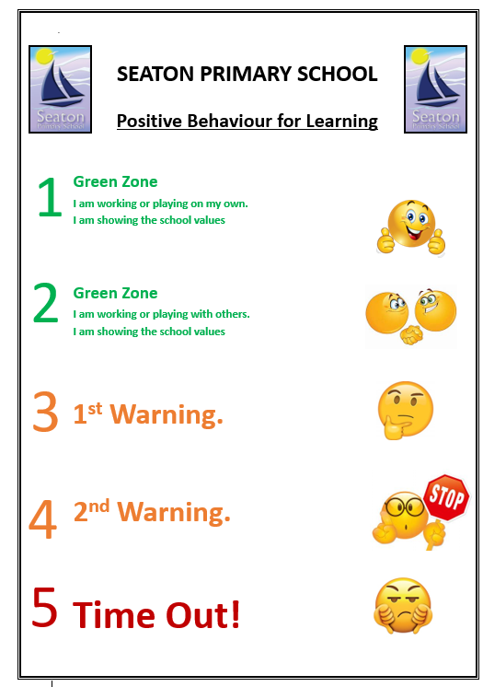
Reminder
Reminder

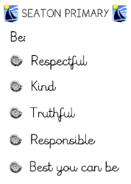


Reflection Sheet 1

Name: __________________________Class: _______ Date: _________________
Complete the first 3 questions while on external ‘Time Out’

 | 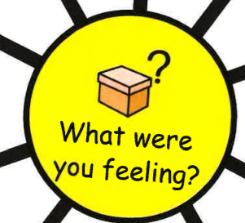
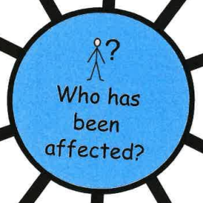 | 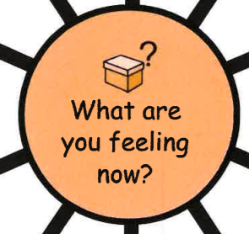

This section is to be completed with a teacher present following a restorative conversation about the answers above.

I have discussed my behaviour with: _____________________________________ (teacher’s name)
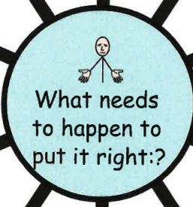


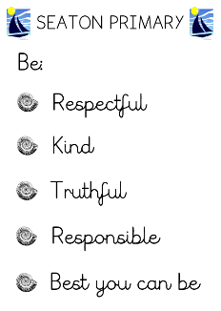

Reflection Sheet 2

Name: __________________________Class: _______ Date: _________________
Complete the first 3 questions while on external ‘Time Out’

What I did and why: (my explanation)

Which school value/s have I broken?

What affect did my behaviour have on others?

This section is to be completed with a teacher present following a restorative conversation about the answers above.
I have discussed my behaviour with: _____________________________________ (teacher’s name)
To fix things I will:

The agreed consequence for my action is:

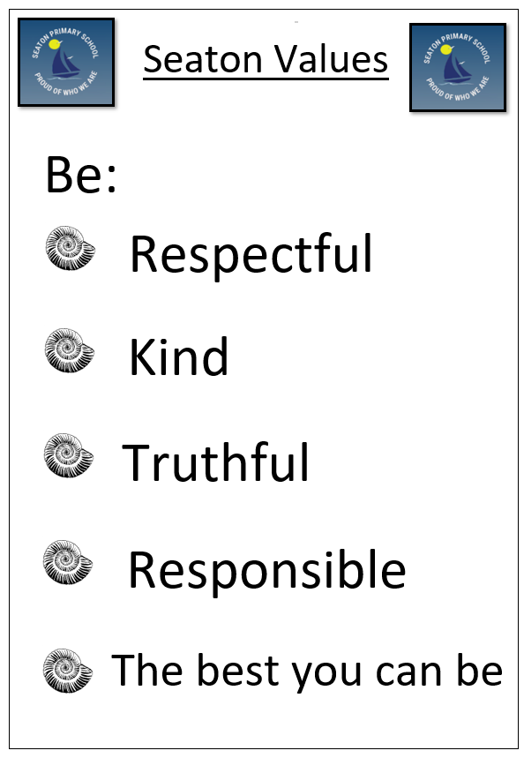

Behaviour Policy – One Pager



