Year 1 Curriculum Coverage - Spring 2
Maths | Reading | Writing
Power Maths  Number Fluency and Mental Arithmetic | Read Write Inc   | Fiction: The Tiger that came to Tea  Poetry: Bugs Galore  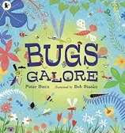  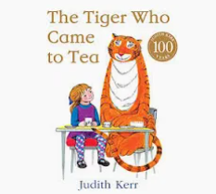
Number and Place Value
Measurement
Class read:  Elmer The Something The Last Tiger  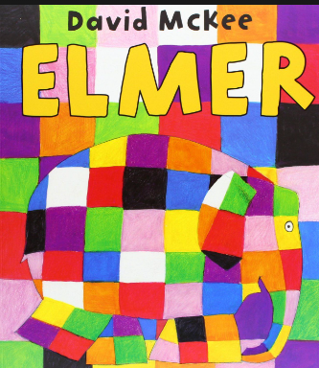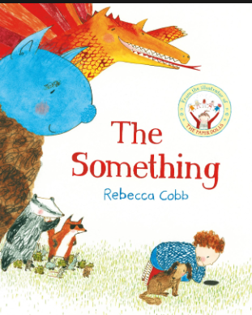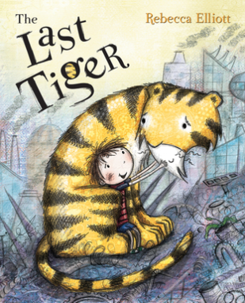 | Trips and outdoor activities:  - Weekly forest school with Mr Hollands  - Local area seasonal walk.  - Field work walk.

 | Science | Geography | Art/D&T | RE | PE | Music | PSHE
Non-core subjects | Plants.  Seasonal changes/Weather | Geography  What is the weather like in the UK? | Kandinsky  Printing Leaf Prints  Drawing: seasonal change observational drawing | Who is Jewish and how do they live? | REAL P.E  Creative  Real Dance | Charanga:  Round and Round  Animal themed | Living in the wider world  Text:  The Last Tiger (Conservation)  My Monster and me (Wellbeing)

