  - Year 2 Curriculum Coverage – Spring 2
Maths | Reading | Writing
Multiplication and Division | Reading comprehension  The big book of the UK  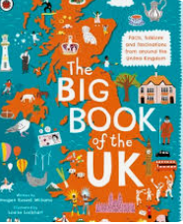  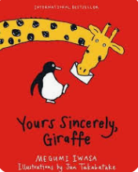  Yours sincerely, Giraffe | Recount of Go Ape  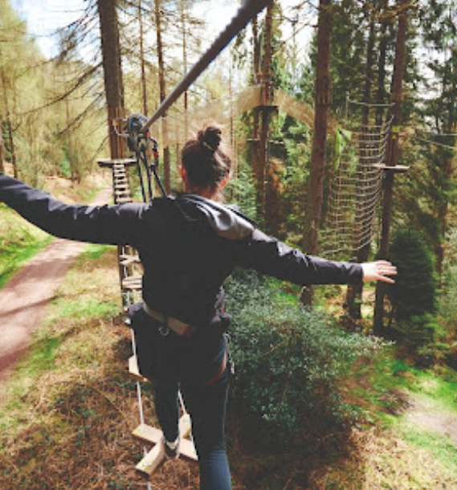 | 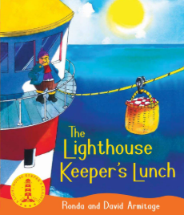  Light house keeper’s lunch | Take a Tale
Length and height
Mass, capacity and temperature
Spelling | 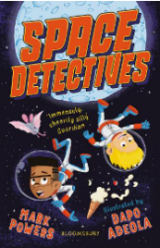  Class book: |  |  | Take a Tale
Year 2 common exception words
Year 2 Spelling Rules
 | Science | History | Art | Computing | RE | PE | Music | PSHE
Topics | Changing materials | The Great Fire of London – Rich Play | Andy Warhol – Pop Art | Pictograms | Why does Easter matter to Christians? | Real PE - | Zoom time | Media literacy and digital resilience  Money and work

