  - Year 2 Curriculum Coverage – Spring 1
Maths | Reading | Writing
Properties of Shapes | Reading comprehension  The Witches  The story of London Underground  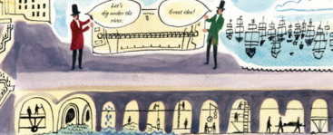  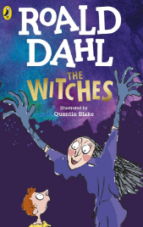 | The Great fire of London  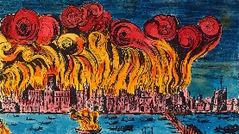 | Fire Poetry  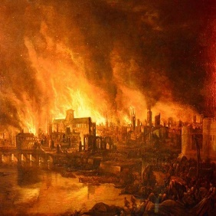 | Take a Tale
Money
Multiplication and Division
Spelling | 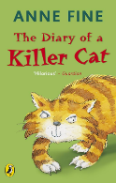  Class book: The Diary of a Killer Cat |  |  | Take a Tale
Year 2 common exception words
Year 2 Spelling Rules
 | Science | History | Art | Computing | RE | PE | Music | PSHE
Topics | Classifying and grouping materials | The Great Fire of London | Great Fire of London painting | Robot algorithms | Why does Easter matter to Christians? | Real PE - Cognitive | I wanna play in a band | Belonging to a community  Media literacy and digital resilience  Money and work

