Year 1 Curriculum Coverage – Spring 1
Maths | Reading | Writing
Power Maths  Numbers to 20 | Read Write Inc   | Fiction: Beegu  The Way Back Home  Non-Fiction: Look Inside Space  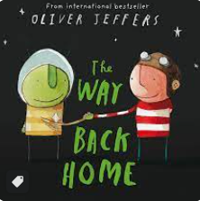  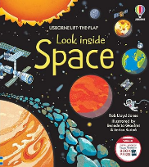  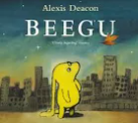
Number and place value
Addition and Subtraction within 20
Class read:  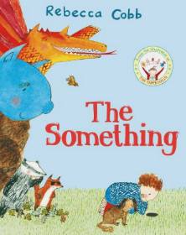  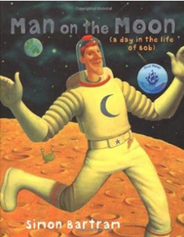  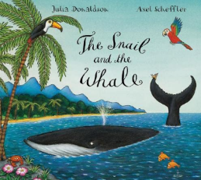 | Trips and outdoor activities:  - Weekly forest school.  - Neil Armstrong – Now Press Play Virtual experience

 | Science | History | Art/D&T | RE | PE | Music | PSHE
Non-core subjects | Seasonal Changes  (Winter)  Materials | The Moon Landing  Neil Armstrong | Painting: Kandinsky  Drawing: Seasonal change observational drawing | What do Christians believe God is like? | REAL Dance  REAL PE:  Cognitive – Balances | Instruments  Pulse  Rhythm  (Space themed) | Belonging to a community  Aspirations  “Astro Girl”  Celebrating Difference  “Amy Wu and the Patchwork Dragon”

