  - Year 2 Curriculum Coverage - Autumn 2
Maths | Reading | Writing
Addition & Subtraction | Reading comprehension  George’s marvellous medicine  Aesop’s Fables  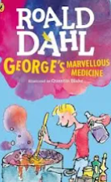  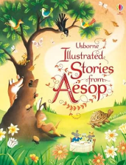  My Dad’s got an Alligator  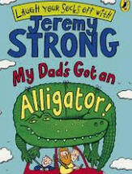 | STUCK  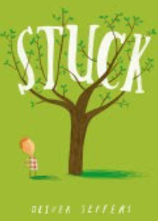 | Mog’s Christmas Calamity  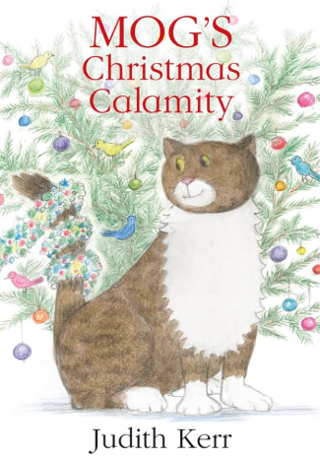
Properties of Shapes
Spelling | Class book: Fantastic
Year 2 common exception words | Class book: Fantastic
 | Science | History | DT | Computing | RE | PE | Music | PSHE
Topics | Animals including humans | Mary Seacole – Why was she important? | How to make a vegetable soup | Digital Photography | The birth of Jesus | Real PE - Social | Nativity Practise | Families and friendships.  Safe Relationships.

  - Year 6 Curriculum Coverage - Autumn 2
Maths | Reading | Writing
The 4 operations | Whole class reading programme  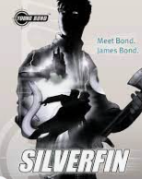  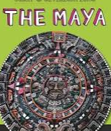  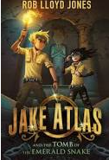 | Non-fiction:  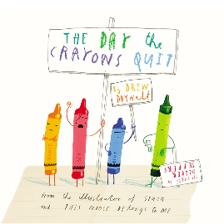  The Day the Crayons Quit | Fiction:  The Princess’ Blankets  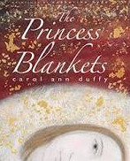
Fractions
Position and Direction
Spelling | 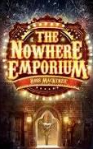  Class book:
Year 5/6 Statutory spelling list and No-Nonsense Spelling

 | Science | History | Art | Computing | RE | PE | PSHE
Topics | Classification | The Mayan Civilisation | Frida Kahlo – self-portraits | Variables in games | What can be done to reduce racism? Can religion help? | Swimming &  REAL PE: Social  Netball | Celebrating Difference

