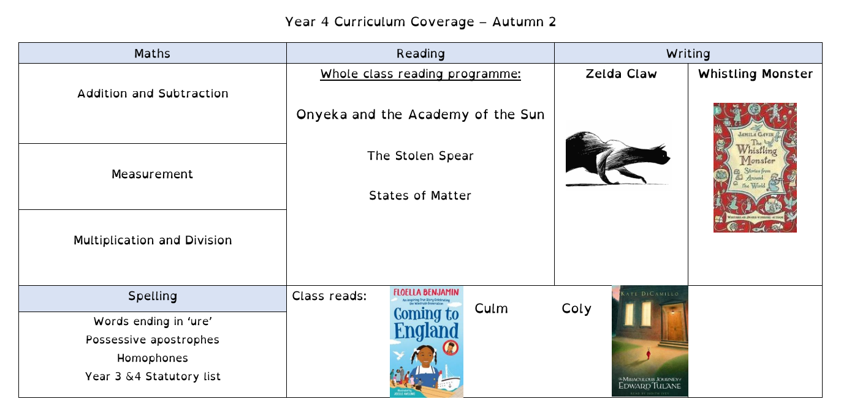
Year 4 Curriculum Coverage – Autumn 2
Huey and The New Jumper
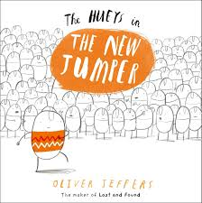

 | Science | Geography | Computing | RE | PE | Art | PSHE | Music
Non-core subjects | States of Matter | Comparing Peninsulas | Audio Production | What is the Trinity and why is it important to Christians | Netball  Real P.E - Social |  | - Respecting ourselves and others  - Families and friendships  - Safe Relationships | Ukulele  Whole class ensemble
Trips and extra-curricular | Roman Baths

