Year 1 Curriculum Coverage - Autumn 2
Maths | Reading | Writing
Power Maths  Addition and Subtraction | Read Write Inc   | Fiction: The Disgusting Sandwich  Non-Fiction: All About Me  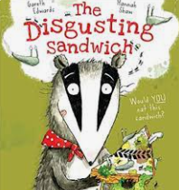  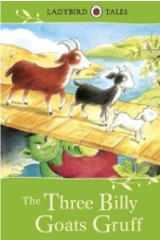
2D and 3D shapes
Numbers to 20
Class read:  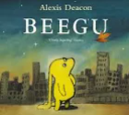  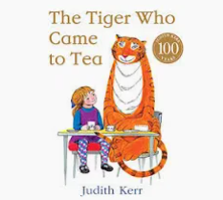  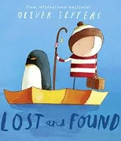 | Trips and outdoor activities:  - Weekly forest school.  - Walk around the school grounds and the woods.  - Nativity

 | Science | History/  Geography | Art/D&T | RE | PE | Music | PSHE
Non-core subjects | Animals including humans.  Seasonal changes/Weather | My school and it’s grounds  Nursery Rhymes | Artist study:  Paul Nash  John Nash  Jasper Johns  DT  Sliders & levers | Who is Jewish and how do Jews live?  (Part 1) | REAL Gym  REAL PE:  Social | Rhythm in the way we walk and The Banana rap  Singing | Celebrating Difference  Families & Friendships  Safe relationships

