Year 1 Curriculum Coverage - Autumn 1
Maths | Reading | Writing
Numbers to 10 | Read Write Inc   | Fiction: Traditional Fairy Tales  Goldilocks and the Three Bears  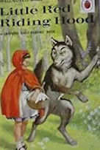  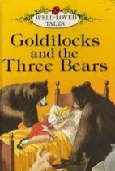  Little Red Riding Hood
Part-whole within 10
Addition within 10
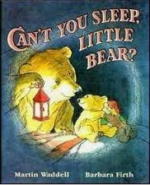  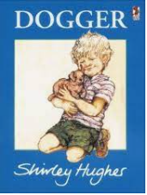  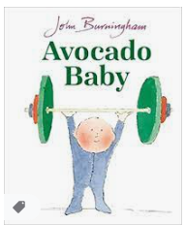  Class read: | Trips and outdoor activities:  - Weekly forest school.  - Walk around school grounds.  - Exploring Seaton.

 | Science | History/  Geography | Art/D&T | Computing | PE | Music | PSHE
Non-core subjects | Animals including humans.  Seasonal changes | What is it like here?  (My school and its grounds) | Drawing seasonal changes  Art study:  Paul Nash | Online Safety  Technology in our Classroom | REAL Gym  REAL PE: Personal | Pulse  “Hey You” | Being me in my world.  Incredible You! (Wellbeing)  Rhys Brisendon  Pantosaurus  (consent)  Respecting ourselves and others

