Year 5 Curriculum Coverage – Autumn 1
Maths | Reading |  | Writing
Place value | 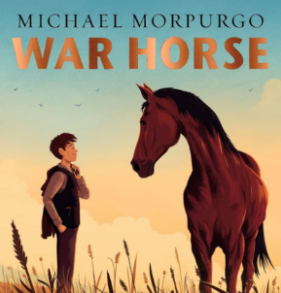  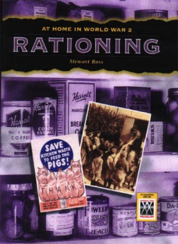  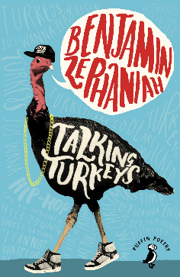  Whole class reading programme:  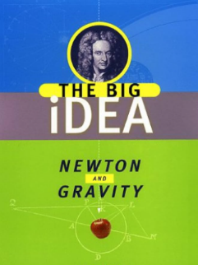 | 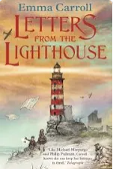  Class book:  PSHE texts:  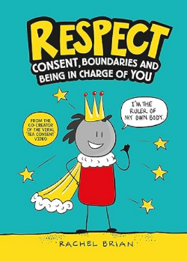  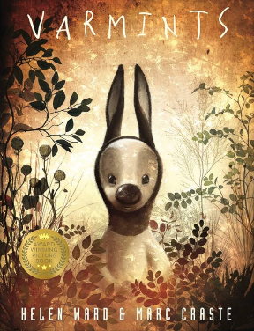 | Fiction: Oktapodi      Non-fiction: For the birds
Addition
Subtraction
Spelling
Weekly spelling rules and strategies taught in class

Year 5/6 spellings

Handwriting
Ensuring letters are the correct size and consistent with fluency

 | Science | History | Computing | RE | PE | Art | PSHE | Music
Non-core subjects | Forces | WW2  Battle of Britain | Search engines and online safety | Why is the Torah so important to Jewish people? | Gymnastics  Outdoor PE:  Personal cog  Coordination and agility | Drawing –  Van Gough | Being me in my world | Living on a prayer
Trips and extra-curricular | WW2 immersive day  Netball at CGS

